**Project Design Phase-I**

**Solution Architecture**

|  |  |
| --- | --- |
| Date | 13 oct 2022 |
| Team ID | IBM-Project-10558-1659186640 |
| Project Name | Project-Deep Learning Fundus Image Analysis for Early Detection of Diabetic Retinopathy |
| Maximum Marks | 2 Marks |

**Solution Architecture:**

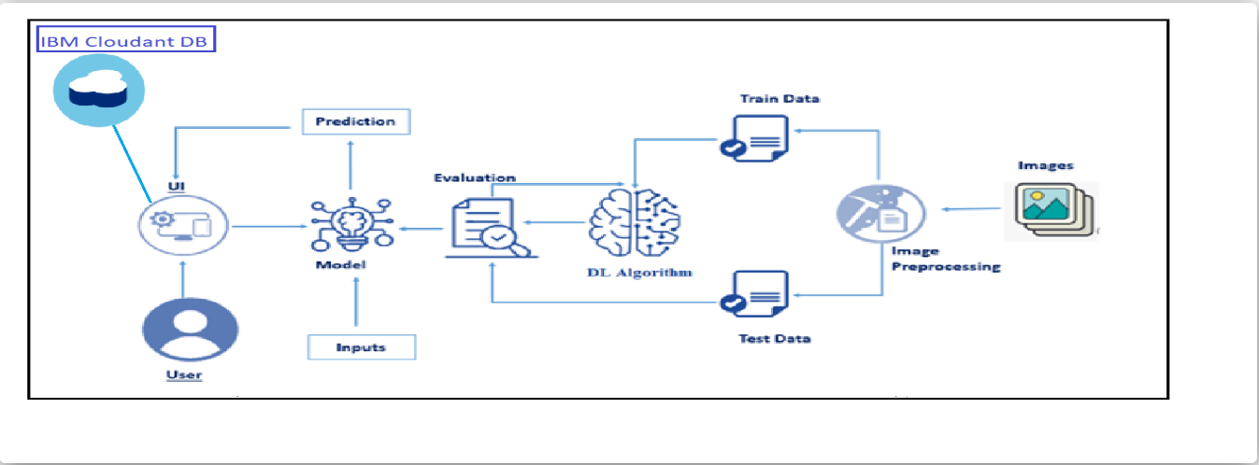

The UI mentioned here can range from a simple scanner application to a large application in computer with scanners for capturing the images of eyes

The Model used here is based on the principle of transfer learning and the model chosen by our team is inception V3 to train and test data